CLAVICLE ORIF POST-OPERATIVE

Weeks 0-2: Primary goals: Protect fixation, control pain/swelling
- Strict no weightbearing until 6 weeks (weightbearing risks catastrophic failure of fixation). To be clear, there is NO lifting, gripping, pushing, or pulling with the operative arm until at least 6 weeks after surgery.
- Sling
- The sling applied in the operating room should remain on and worn while up and moving. Do sleep with the sling with pillows that prop up the arm for comfort at nighttime. Remove the sling only for hygiene and gentle shoulder exercises.
- Elevate the shoulder and use ice 20 minutes on at a time to reduce swelling.
- Transient ulnar (pinky) sided hand numbness and tingling can occur from the elbow being flexed in the sling. If this occurs, adjust the sling and move the elbow
- Motion
- Maintain motion of the uninvolved fingers, the wrist, and the elbow to prevent unnecessary stiffness. Move these multiple times daily
- Pendulum exercises should begin first day after surgery to gently move the shoulder (see attached exercises)
- No shoulder elevation above 90 degrees or across the midline of the body.
- At 2 week visit: Remove sutures, new XR, start therapy
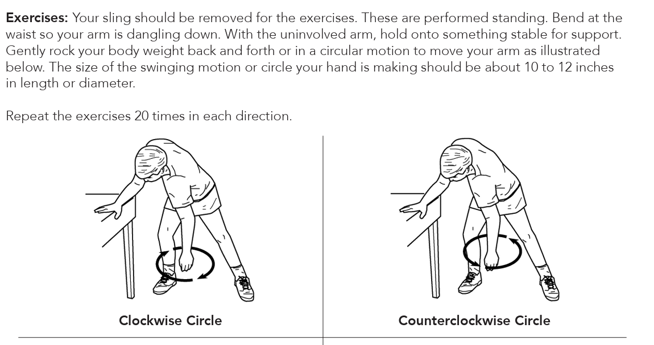

Weeks 2-6: Primary goals: Protect fixation, start gentle motion
- Strict no weightbearing until 6 weeks, cannot lift > than 1-2 pounds with the operative arm. Use the arm just for simple daily activities such as hygiene and feeding.
- Sling for comfort, can come out for exercises of the shoulder, elbow, wrist, and fingers several times a day to prevent stiffness.
- No driving until completely off narcotic pain medications, patient can perform an emergency stop safely, and patient can control the steering wheel safely first in an empty parking lot. This is usually around the 2-4 week postoperative time period.
- Begin focused therapy twice a week + a daily home exercise program:
- Progress from passive to active-assisted ROM:
  - Flexion/scaption to 120°
  - Abduction to 90°
  - Begin gentle external rotation to tolerance
  - Full extension
- Scapular stabilization and posture drills
- Continue elevation and ice to reduce swelling
- Gentle scar massage with Vitamin E lotion if the incision is well healed
- At 6 week visit: New XR, progress therapy, discontinue sling

Weeks 6-10: Primary goals: Restore motion, light strengthening
- Weightlifting progression
- At 6 weeks, allowed to use the hand for simple daily activities. Weightlifting allowed up to 5 pounds until 9 weeks.
- At 9 weeks, weightlifting allowed up to 15 pounds.
- Progress weightbearing only if pain free and XR continue to show fracture healing with bony union.
- Therapy
• Advance to full AROM as tolerated with goal of achieving near-full AROM in all planes. Motion should be pain free.
• Initiate light strengthening only after surgeon confirms radiographic union with bridging callus at the fracture site. Light strengthening includes:
- Gentle rotator cuff and deltoid isometrics
- Light resistance band exercises for external rotation, rows, and scapular work
- Continue scapular control and postural training
- At 10 week visit: New XR, progress therapy

Weeks 10-16: Primary goals: Restore strength, endurance, and dynamic stability
- Weightlifting progression
- At 12 weeks, if radiographic union and patient has pain-free motion, they may progress without restrictions. However, until 12 weeks, do not perform any heavy lifting or significant contact activity/sports
- Progress weightbearing only if pain free and XR continue to show fracture healing with bony union
- Focused therapy
- Progress resistance band and light dumbbell program
- Add closed-chain kinetic exercises (wall push-ups, quadruped weight shifts)
- Incorporate proprioception and rhythmic stabilization drills
- Cardiovascular activity as tolerated such as stationary bike and elliptical
- Advance strengthening and work-specific activities. Return to sport or heavy labor typically around 12-14 weeks depending on fracture healing and hand demands. For contact, collision, or power-grip sports, written surgeon clearance is required.
- At 16 week visit: Final XR

Weeks 16+: Primary goals: Full, pain-free ROM and strength ≥90% of contralateral side.
- Therapy
- Therapy is optional at this point but if there is any stiffness, should continue with therapy
- Progressive resistance and plyometric training as appropriate
- Sport-specific and functional drills under supervision.
- Clearance for unrestricted activity with a safe return to work, sports, and/or overhead activities is allowed once clinical and radiographic union is achieved.
- Expect gradual resolution of stiffness and swelling as patient returns to normal life
- Although most daily function returns by 3 months, full recovery of strength and motion can take up to 6-12 months especially for patients in heavy labor.

ALWAYS contact the office if new pain, redness, drainage, or the inability to use the hand develops.

Remember, the use of nicotine (cigarettes or vaping) or the presence of vascular disease will slow down the time to union and has a higher risk of fixation failure

