ROTATOR CUFF POST-OPERATIVE

General Principles:
• Healing timeline: Tendon-to-bone healing is biologically weakest in the first 6 weeks, stronger by 12 weeks, and continues to remodel up to 6–12 months.
• Priorities: Protect repair → restore passive motion first → restore active motion second → restore strength and function last.
• Key risks: Stiffness from over-immobilization vs. retear from too aggressive rehab.
• Precautions: No lifting, pushing, pulling, or supporting body weight on operative arm until cleared
• Large/massive tears, revision repairs, patients who smoke, or diabetic patients should all have slower rehab to help protect the repair that is biologically challenged. Specifically, their rehab should lag behind around 2-4 weeks to help the cuff heal properly before loading.
• Red Flags for which patients should call the office immediately:
-Concern for retear of the repair: Increasing pain, loss of motion after initial gain of motion, popping with loss of function
-Concern for infection at the operative site: Fever/chills or drainage from incision

Typical Follow up Schedule:
• 2 weeks: Wound check, Suture removal, XR only if needed (rare).
• 6 weeks: Assess passive ROM, cuff integrity, and transition to active ROM
• 12 weeks:
-Evaluate strength, begin resistance training
-Most patients regain normal daily function by 3–4 months post surgery
• 6 months: Assess functional recovery.
• 12 months:
-Final clearance
-Full tendon healing and maximal strength recovery takes up to 9–12 months.
-We know that small tears have a faster recovery while large or massive tears have a slower recovery and are more prone to stiffness. This is why any patient undergoing rotator cuff surgery must be mentally prepared for the long rehab ahead of them to get the best results.
-Mild soreness or swelling is common up to 1 year after surgery
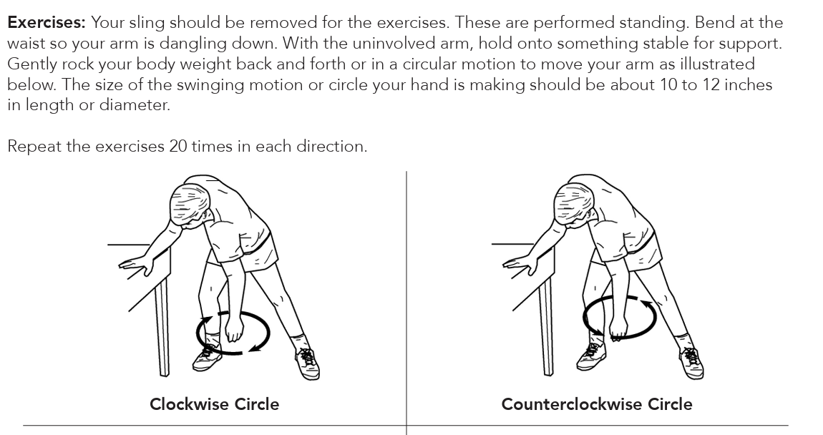

POST-OPERATIVE PHASE
Weeks 0-2
Primary goals: Protect repair, control pain/swelling, maintain mobility of the elbow/hand
- Sling directions:
- The sling with the provided abduction pillow should be worn at all times including at night.
- The brace should only be unlocked for hygiene/showering and for hygiene, the arm is locked in to the side of the body.
- The brace is also unlocked for therapy under supervision
- ROM:
- No active motion of the shoulder is allowed in order to protect the repair.
- Gentle controlled pendulums of the shoulder allowed early to safely mobilize the shoulder joint without damaging the repair. See the first page for a description of these exercises. Remember, pendulums should be gentle, the motion is generated by the body swaying and NOT from a forceful contraction of the shoulder muscles.
- Full elbow extension/flexion (come out of the sling to work on this)
- Move the wrist and fingers to prevent swelling and stiffness.
- Therapy modalities:
- Scapular retraction
- Dry needling of the trapezius is very helpful to let the shoulder relax after it has been operated on and to facilitate gentle motion. This is up to the therapist discretion but highly encouraged if patient agreeable to this as well

Weeks 2-6
Primary goals: Gradually restore PROM without stressing repair
- Should continue the sling with pillow as in weeks 0-2 and remove for hygiene/exercises
- Goals for motion
- By 4 weeks: Passive FF to 90, ER to 20 at the side
- By 6 weeks: Passive FF to 140, ER to 40 at the side
- Therapy modalities
- Passive motion goals as above. Table slides are helpful.
- Gentle scapular mobility/dry needling if needed
- Begin pulley-assisted motion around weeks 5-6 if comfortable. If the cuff tear is large/massive, revision case, smoker, or diabetic, do NOT do pulleys at this phase.

Weeks 6-12
Primary goals: Restore AROM, normalize scapulohumeral mechanics, avoid overload
- After seen and cleared in clinic, can discontinue the postoperative sling
- Goals for motion: Progress to full PROM, then active-assisted motion, then active motion.
- Therapy modalities:
- Continue scapular stabilization and postural exercises especially in weeks 6-8. Examples include:
  - Scapular retraction/depression
  - Serratus punches: Supine with arm in 90 degrees of flexion, patient protracts the scapula upwards
  - Prone Y/T/W: Performed on either a table or a Swiss ball to active the lower traps and rhomboids
  - Chin tucks
- Gentle isometric exercises of the rotator cuff and deltoid are allowed at 8-10 weeks postop
- Restrictions
- No resisted strengthening is allowed
- No lifting > 2-3 pounds is allowed with the operative arm

Months 4-6
Primary goals: Improve cuff and periscapular strength/endurance
- Goals for motion: This far out, patient should have near full and pain free range of motion
- Strengthening
- Therabands:
  - Start with very light bands.
  - Start with Theraband ER at the side > Theraband rows > prone work > overhead work at last
  - Avoid overhead or resisted ER at 90 degrees abduction until at least month 5
- Light weights only from 1-2 lbs allowed initially. Progress to up to 5 lb weights only if the motion is completely pain-free and there is no compensatory substitution noted during the exercise.
- Closed-chain exercises, rows, wall push-ups
- Continue scapular strengthening and coordination of the whole kinetic chain
- Precautions: Avoid sudden heavy lifting or explosive overhead movements that can suddenly stress the rotator cuff

Months 6-9
Primary goals: Power, endurance, and safe return to functional activity and sport
- Strengthening progression:
- Plyometrics > proprioception > dynamic stability
- Sport-specific or work-hardening exercises (i.e manual labor patients)
• Return to activity
- Return to golfing, swimming, and regular gym activity is typically allowed around 5–6 months after surgery
- For overhead or throwing athletes (volleyball, baseball, javelin), return is typically around 8-9+ months out from surgery
- Any return to contact/collision sports or heavy manual work should have a formal sports clearance or work clearance by Dr. Charls at follow-up.

